ONLINE COMPLAINT REGISTRATION
AND MANAGEMENT SYSTEM
Project Documentation
Technology Stack: MongoDB · Express.js · React.js · Node.js (MERN)
TECHNICAL ARCHITECTURE

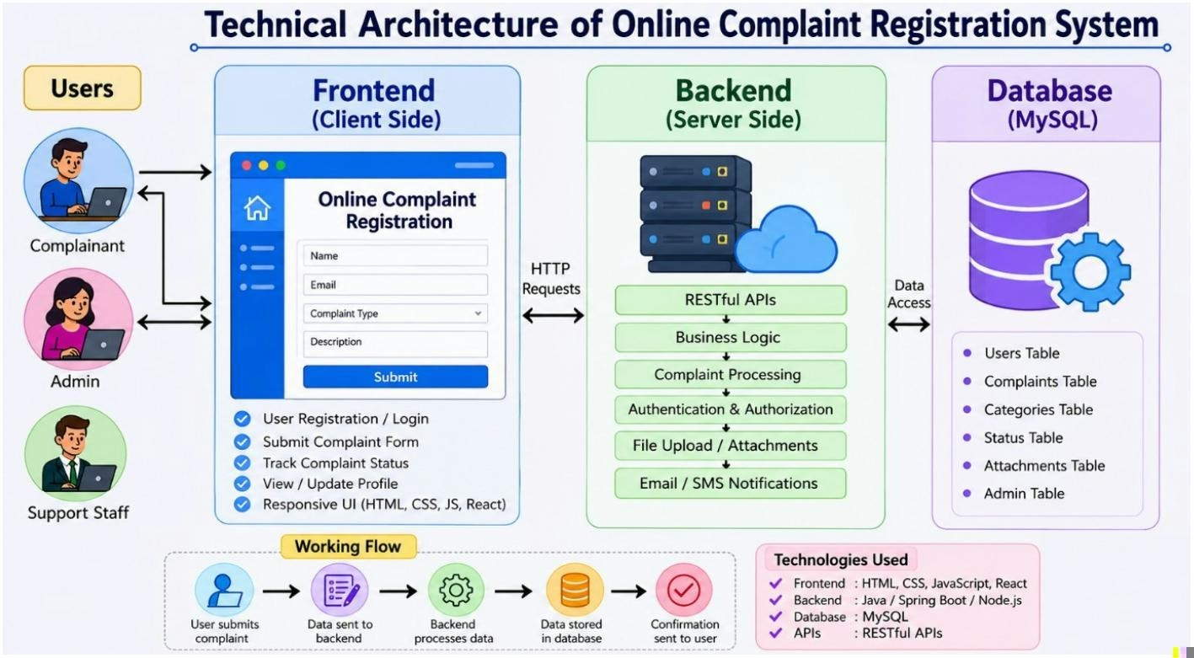
The Technical Architecture of our Online Complaint. Registration System follows a client-server architecture, where the frontend works as the client and the backend works as the server. The frontend provides a simple and user-friendly interface for users and admins to register complaints, view details, and track complaint status. It is developed using HTML, CSS, JavaScript, and Bootstrap and communicates with the backend using REST APIs. The backend handles the application logic, user authentication, complaint management, and data processing. It is developed using Java with Spring Boot. The system uses MySQL database to store user information, complaint details, and status updates securely. Together, the frontend, backend, APIs, and database provide a reliable platform for users to submit complaints and for administrators to manage and resolve them efficiently.
ER DIAGRAM
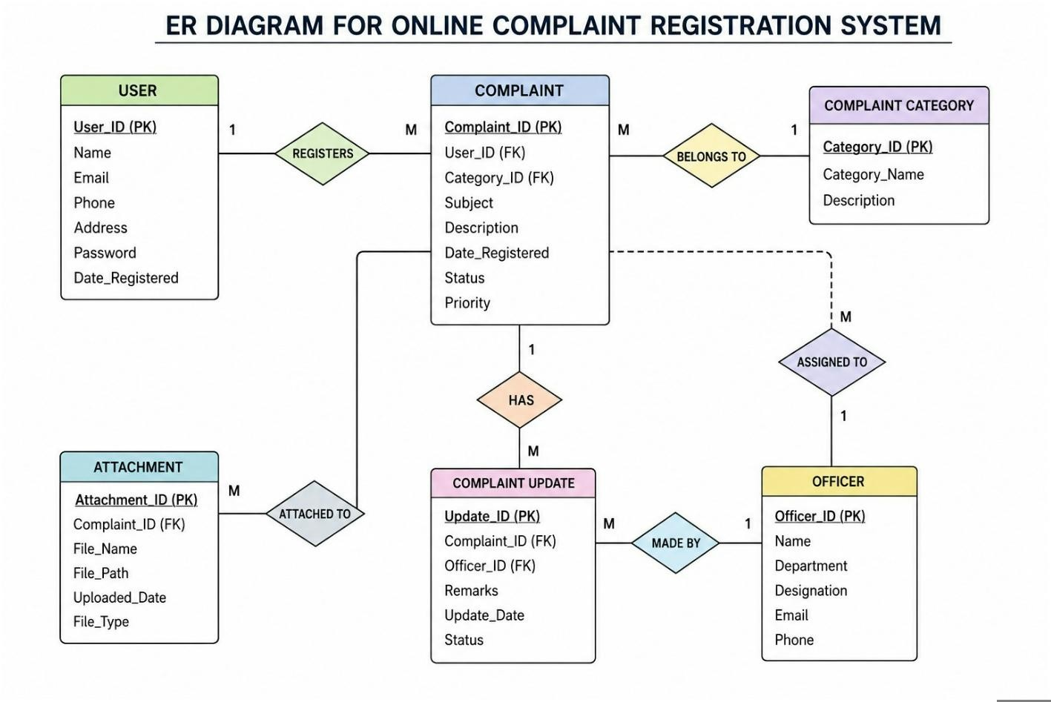This ER diagram represents the Online Complaint Registration System. It shows the relationship between users, complaints, agents, and messages. Users can register and submit complaints by filling in the required details. Each complaint is assigned to an agent for review and resolution. The diagram also includes a chat feature that allows users and agents to communicate regarding a complaint. Messages are linked using the User ID and Complaint ID to ensure proper tracking of conversations. Overall, the ER diagram helps in understanding the database structure and the flow of information within the system.

FEATURES

User Registration
User Registration: Users can create an account by providing their email address and password to access the complaint management system.
Profile Management: Users can maintain their personal information, such as name, contact details, and address, for easy complaint tracking.

Complaint Categories
Category Selection: Users can choose the appropriate complaint category before submitting their complaint.
Department Filtering: The system helps users identify the relevant department responsible for handling their issue.

Complaint Submission
Online Complaint Submission: Users can submit complaints by providing details of the issue and uploading supporting documents or images.
Complaint Tracking: Users can monitor the status of their complaints from submission to resolution.

Officer Dashboard
Complaint Assignment: Officers can view and manage complaints assigned to their department.
Status Updates: Officers can update complaint progress, add remarks, and provide resolution details.

Admin Management
Officer Approval: Administrators verify and approve officer accounts to ensure authorized access.
System Monitoring: Admins oversee complaint activities, manage users, and generate reports for effective system management.

Notifications & Communication
Automated Notifications: Users receive updates regarding complaint submission, status changes, and resolution.
User–Officer Communication: The system enables communication between users and officers for clarifications and complaint follow-up.

ROLES AND RESPONSIBILITIES
- User Registration
Example:
Priya wants to report a streetlight that is not working in her area. She visits the Online Complaint Registration System and creates an account by entering her name, email address, phone number, and password. After successful registration, she logs into the system.
- Selecting Department & Complaint Category
Example:
Priya navigates through the available departments such as Electricity, Roads, Water Supply, and Sanitation. Since her issue relates to a faulty streetlight, she selects the Electricity Department and chooses the Streetlight Maintenance category.
- Submitting a Complaint
Example:
Priya fills out the complaint form by describing the problem, providing the location details, and uploading a photo of the damaged streetlight. She then submits the complaint through the portal.
- Complaint Acknowledgement
Example:
After submission, the system generates a unique complaint ID and sends a confirmation notification to Priya via email. The complaint is forwarded to the concerned department for review.
- Complaint Status Tracking
Example:
Using her dashboard, Priya can monitor the complaint status, view updates from officers, and check whether the complaint is pending, under process, or resolved.
- Admin Verification
Example:
The system administrator verifies officer accounts and department access rights. This process ensures that only authorized personnel can handle complaints and update records.
- System Monitoring
Example:
The administrator monitors complaint activities, generates reports, manages escalated cases, and ensures the smooth operation and security of the platform.
- Officer Complaint Handling
Example:
An officer from the Electricity Department reviews Priya’s complaint, assigns it to a maintenance team, and updates the complaint status with remarks regarding the repair process.
- Issue Resolution
Example:
The maintenance team repairs the streetlight and submits proof of completion. The officer marks the complaint as resolved, and Priya receives a notification confirming that the issue has been successfully addressed.
USER FLOW

User (Citizen)
Role: Register complaints, track complaint progress, communicate with officers, and manage account details.
Flow:

Account Creation and Login
- Register using email, phone number, and password.
- Log in securely to access the complaint portal.

Complaint Registration
- Select the appropriate department and complaint category.
- Enter complaint details and upload supporting documents or images.
- Submit the complaint and receive a unique complaint ID.

Complaint Monitoring
- View all submitted complaints from the dashboard.
- Track complaint status such as Submitted, Under Review, In Progress, and Resolved.

Communication
- Exchange messages with the assigned officer regarding complaint updates.
- Provide additional information when requested.

Profile Maintenance
- Update personal information and contact details.

- View complaint history and previous resolutions.

Officer
Role: Handle assigned complaints, communicate with users, and update complaint progress.
Flow:
Registration and Login
• Create an officer account and log in using authorized credentials.

Complaint Handling
- Access assigned complaints through the officer dashboard.
- Review complaint details and supporting documents.

Complaint Processing
- Investigate issues and coordinate necessary actions.
- Add remarks, upload reports, and update complaint status.

User Communication
- Respond to user queries and provide progress updates.

- Request additional information when needed.

Administrator
Role: Manage the entire complaint management system, supervise officers, and ensure efficient complaint resolution.
Flow:

System Administration
- Monitor platform activities and complaint statistics.
- Ensure smooth functioning of the system. Complaint
Allocation
- Assign complaints to appropriate officers based on department and workload.
- Track pending and escalated complaints.

User and Officer Management
- Approve officer registrations and manage user accounts.
- Control access permissions and system roles.

Performance Monitoring
- Review complaint resolution rates and officer performance.
- Generate reports and analytics for decision-making.

Platform Maintenance
- Enforce security policies and data protection measures.
- Implement system improvements and resolve operational issues.

MVC Pattern

Description
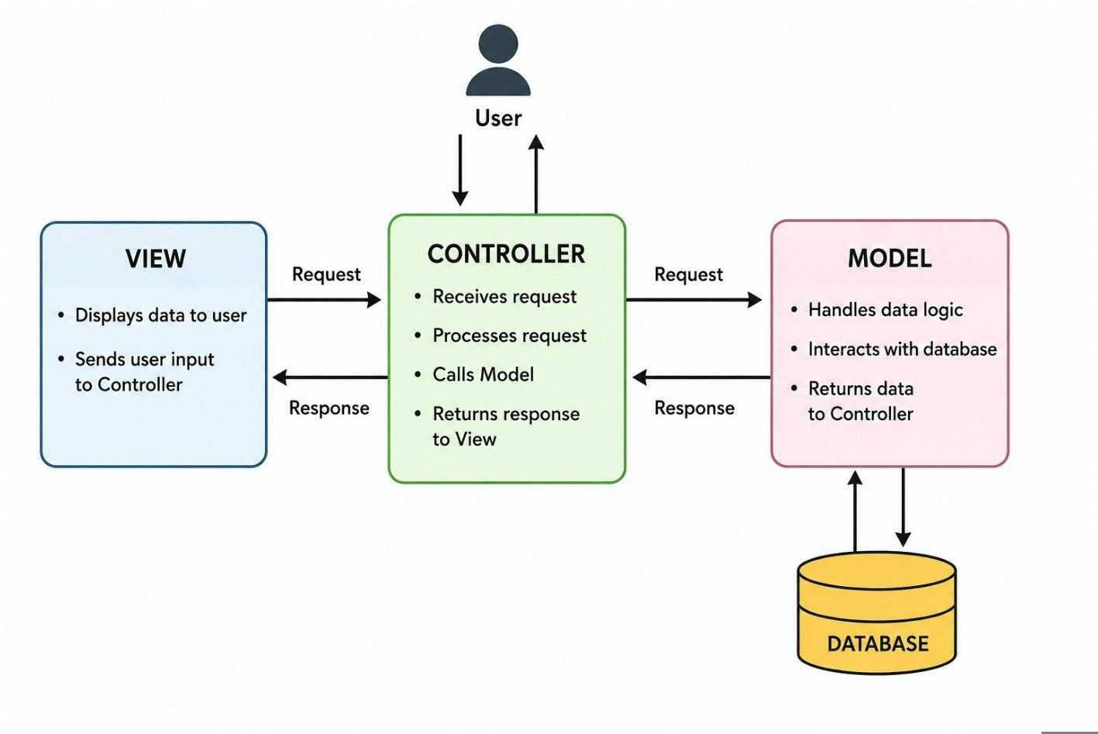

MVC Architecture
The Online Complaint Registration System is developed using the Model-View-Controller (MVC) architecture. MVC divides the application into three independent components, making the system organized, maintainable, and easy to expand.

Model Layer (Data Management)
The Model layer manages all application data and database operations. It defines the structure of entities such as Users, Complaints, Officers, Messages, and Administrators. The model is responsible for storing, retrieving, updating, and deleting information from the database while ensuring data consistency and integrity.

Controller Layer (Business Logic)
The Controller layer processes requests received from users and system administrators. It acts as a bridge between the View and the Model by handling business logic, validating user input, processing complaint submissions, managing complaint assignments, and updating complaint statuses. After processing the request, it returns the appropriate response to the user.

View Layer (User Interface)
The View layer represents the user-facing part of the application. It includes pages such as Registration, Login, Complaint Submission, Complaint Tracking, Officer Dashboard, and Admin Dashboard. The view collects user input and displays information received from the controller in a user friendly format.
Advantages of MVC Architecture in This Project Modular
Design: Each component performs a specific function, making the application easier to understand and maintain.
Easy Maintenance: Changes in one layer have minimal impact on the other layers, reducing development complexity.
Scalability: Additional modules and features can be integrated without affecting the existing structure.
Code Reusability: Controllers and models can be reused across different modules of the system.
Improved Testing: Individual layers can be tested independently, improving software quality and reliability. Team Collaboration: Developers can work on the user interface, business logic, and database components simultaneously, increasing productivity.

CLIENT SETUP (installing react app)

Description

Setting Up the React Frontend
- Open the Client folder in Visual Studio Code and launch the terminal.
- Create a new React project using Vite by running the following command:
npm create vite@latest . -- --template react
- When prompted, choose the following options:

o Framework: React o Variant: JavaScript
- Move to the client project directory:
cd client
- Install the required dependencies:
npm install
- Start the development server:
npm run dev
- After the server starts successfully, open the URL displayed in the terminal (usually http://localhost:5173) to view the React application in your browser.

SERVER SETUP (npm init)

Backend Server Configuration
- Open the Server folder in Visual Studio Code and launch the terminal.
- Initialize a new Node.js project by executing the following command:
npm init -y
- This command generates a package.json file with default project settings.
- Create the main server file:
server.js
- Organize the project structure by creating the following directories:
controllers/ models/ routes/
- The purpose of each folder is:
  - models – Contains database schemas and data related logic.
  - controllers – Handles application logic and request processing.
  - routes – Defines API endpoints and connects them to controllers.
- After creating the files and folders, the basic backend structure is ready for developing REST APIs and database integration.

DEVELOPMENT AND EXPLANATION

Project Setup
The development process begins by creating the server project and initializing it using the npm init command. Required packages such as Express.js, Mongoose, CORS, JWT, and other dependencies are installed to support backend functionality.

Express Server Creation
An Express.js server is configured to handle client requests and provide API services. Middleware such as JSON parsing and
CORS is added to process request data and enable communication between the frontend and backend.

Route Development
Separate route files are created for different modules, including authentication, complaints, users, agents, and chat functionality. These routes define the available API endpoints and direct requests to the appropriate controllers.

Controller Implementation
Controllers are developed to handle application logic. They receive requests from routes, process the required operations, interact with database models, and send responses back to the client.
Database Model Creation Mongoose schemas and models are created for entities such as Users, Complaints, Agents, Messages, and Admins. These models define the database structure and facilitate interaction with MongoDB.
Complaint Management
The complaint module allows users to create complaints, view complaint details, track status updates, and communicate with assigned agents. Agents can update complaint progress and provide resolutions.

User Authentication
Authentication is implemented using JSON Web Tokens (JWT). Users and agents can register and log in securely, while protected routes are accessible only to authorized users.

Admin Operations
Admin-specific features are developed to manage users, agents, and complaints. Administrators can assign complaints, monitor platform activities, and oversee complaint resolution processes. Chat Functionality
A messaging system is implemented to enable communication between users and agents. Messages are stored in the database and linked to the relevant complaint for easy tracking.

Error Handling
Error-handling middleware is added to catch application errors and return meaningful error messages with appropriate HTTP status codes, improving system reliability and debugging.

System Testing
All modules are tested to ensure smooth functionality. APIs are verified, database operations are validated, and authentication and complaint workflows are checked for accuracy and performance.

CONFIGURE MONGODB

Install Mongoose
Mongoose is used to connect the Node.js application with the MongoDB database and perform database operations.
Run the following command in the terminal:
■ npm install mongoose
After installation, Mongoose can be used to create database schemas, models, and connect the application to MongoDB.

CREATING FOLDER STRUCTURE
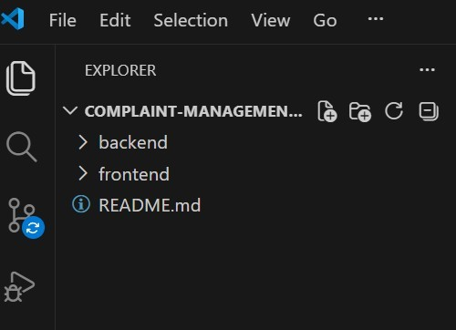
The project is organized into a well-structured directory layout that separates the frontend and backend components, making the application easier to develop, maintain, and scale. The backend folder contains the server-side logic, including APIs, database models, routes, middleware, and configuration files. The frontend folder includes the user interface built with React, containing components, pages, assets, and styling files. This separation of concerns improves code readability and enables independent development and deployment of both modules. The README.md file provides project information, installation steps, and usage instructions for developers. Overall, this organized folder structure enhances maintainability, collaboration, and efficient project management.

BACKEND FOLDER STRUCTURE
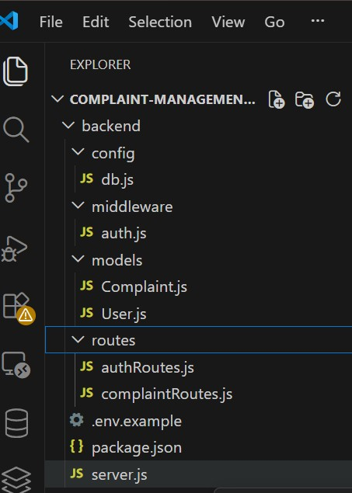
The Backend folder contains the complete server side implementation of the Complaint Management
System and is responsible for processing client requests, managing business logic, and communicating with the database. The config directory includes the db.js file, which establishes a secure connection with the MongoDB database. The middleware folder contains the auth.js file, which implements JWT (JSON Web Token) Authentication to ensure secure access to protected resources. The models directory defines the User and Complaint schemas using Mongoose, providing a structured representation of data stored in the database. The routes folder manages all RESTful API Endpoints, including User Authentication and Complaint Management functionalities, ensuring organized request handling. The server.js file acts as the main entry point of the application by initializing the Express.js Server, configuring middleware, and registering API routes. Additionally, the package.json file manages project dependencies, scripts, and package information, while the .env.example file provides a template for Environment Variables, enhancing application security, configuration management, and deployment flexibility.

CREATE DATABASE CONNECTION
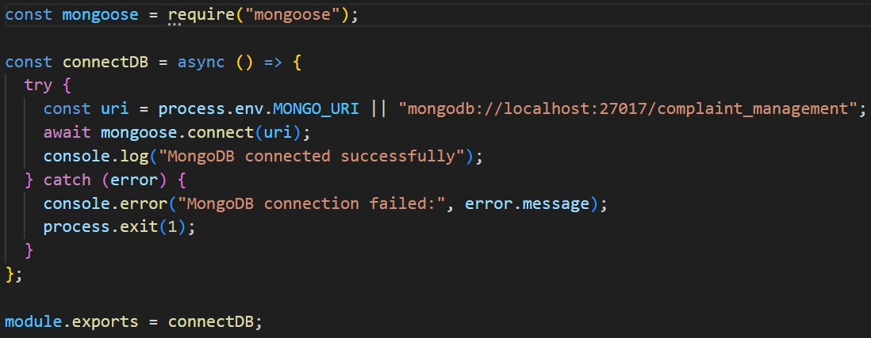

SCHEMA AND MODELS
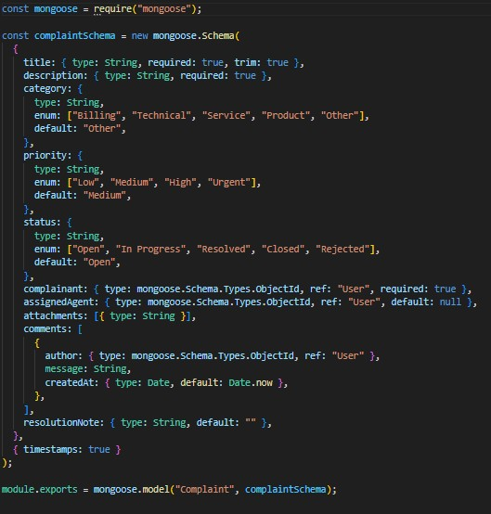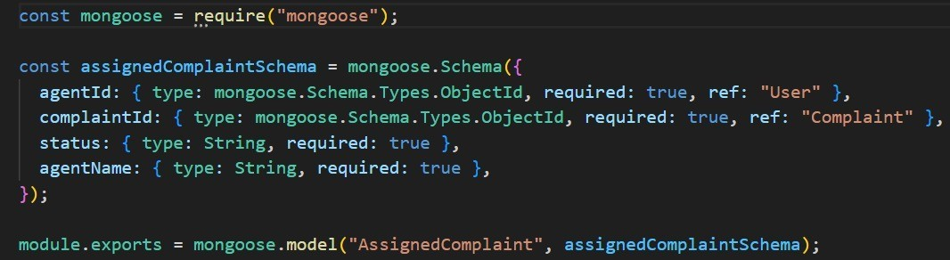

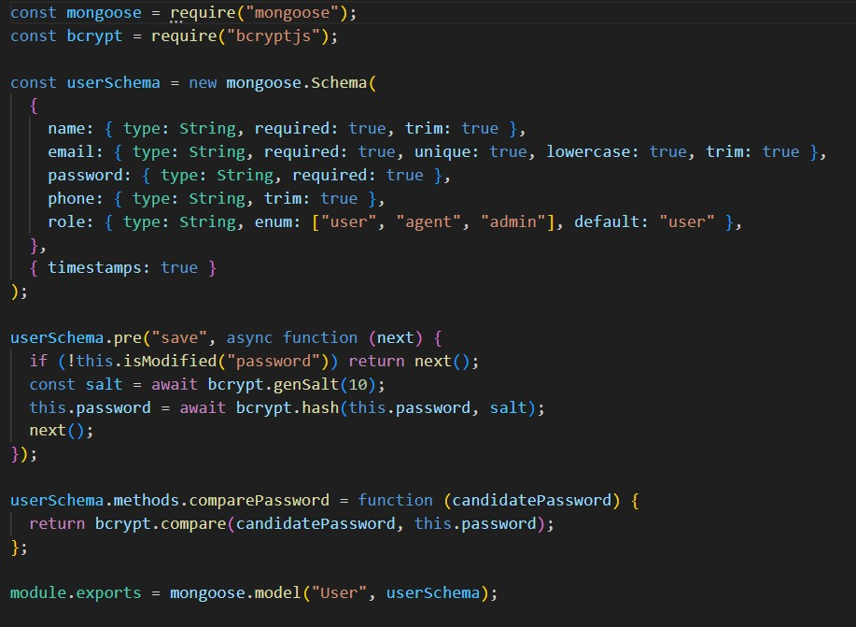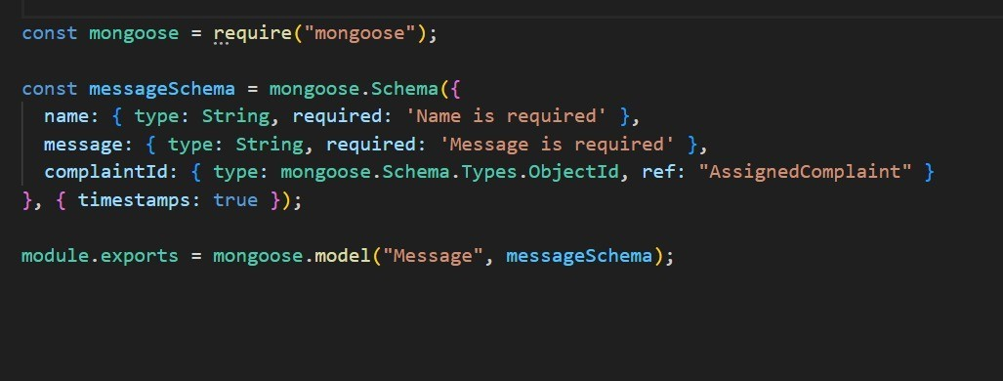
- Imports Mongoose, which provides schema-based modeling and convenient MongoDB
- operations in Node.js.
- Declares a function called connectToDB. This will be called in your main server file (server.js or app.js) to initiate the DB connection.
- Connects to MongoDB using the connection URI stored in process.env.MONGO_DB.
- The second argument is an options object:
- useNewUrlParser: true ensures the new MongoDB connection string parser is used.
- useUnifiedTopology: true uses the new Server Discovery and Monitoring engine, which handles replica sets and sharding better.
- If the connection is successful, it logs a confirmation message.
- If the connection fails, it throws an error with a message.
- It’s a good practice to handle this error gracefully instead of just throwing it. You could console.error() and exit the process using process.exit(1) if needed.
- Exports the connectToDB function so it can be used in other files, like your server.js:

FRONTEND FOLDER STRUCTURE
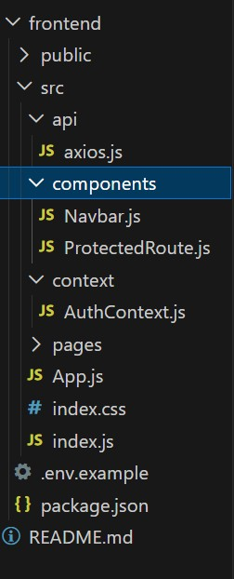

1.Setup React Application
The frontend folder contains the complete client side implementation of the Complaint
Management System, developed using React.js. The application structure is organized inside the src directory to maintain clean, reusable, and scalable code. The api folder contains axios.js, which is used to connect the frontend with backend REST API endpoints. The components folder includes reusable UI elements such as Navbar.js for navigation and
ProtectedRoute.js for securing private pages. The context folder contains AuthContext.js, which manages user authentication state across the application. The pages folder stores different screen level components such as login, register, dashboard, and complaint-related pages. The App.js file handles application routing, while index.js renders the React application into the browser. The index.css file manages global styling, and package.json maintains required frontend dependencies and scripts.

2.Design UI Components
The UI components are designed using React.js to provide a clean, responsive, and user-friendly interface for the Complaint Management System. The Navbar.js component provides smooth navigation between different pages such as Home, Login, Register, Dashboard, and Complaint
Management. The ProtectedRoute.js component ensures that only authenticated users can access secure pages. The application layout is structured through the pages folder, where each page represents a specific screen or feature. This component-based design improves code reusability, maintainability, and consistent user experience across the application.

3.Implement Frontend Logic
The frontend logic connects the user interface with the backend services using Axios through the axios.js file. It handles API communication, including user login, registration, complaint creation, complaint viewing, and complaint status tracking. The AuthContext.js file manages the complete authentication state, stores user details, and controls login/logout functionality across the application. The App.js file manages routing and connects public and protected pages.

PROJECT EXECUTION
Steps for Project Execution:
Step 1: Download the Project
cd App
Step 2: Install Frontend Dependencies
cd frontend
npm install
npm run dev
Step 3: Install Backend Dependencies
cd ../backend
npm install
Step 4: Create a .env file with your MongoDB URI:

MONGO_URI=mongodb://localhost:27017/OnlineCompla int Registration

DEMO SCREENSHORTS
Output ScreenShots :
- Landing Page : Displays a welcome message with options to login or register.
Serves as the entry point for all users (User, Admin, Agent).
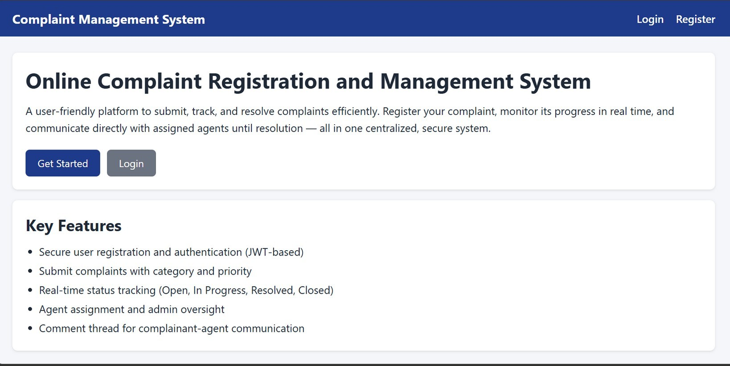
- Login Page : Shows a form with email and password fields.
On successful login, redirects user to their respective dashboard.
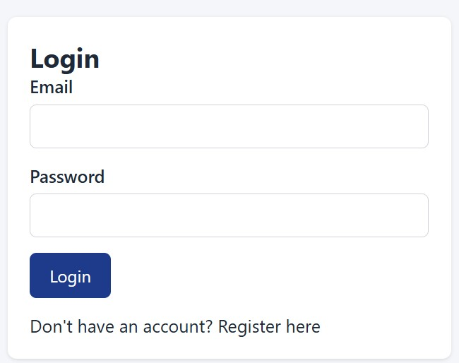
- Registration Page : Provides a form for new users to sign up with basic details.
Shows a success message and redirects to the login page upon registration.
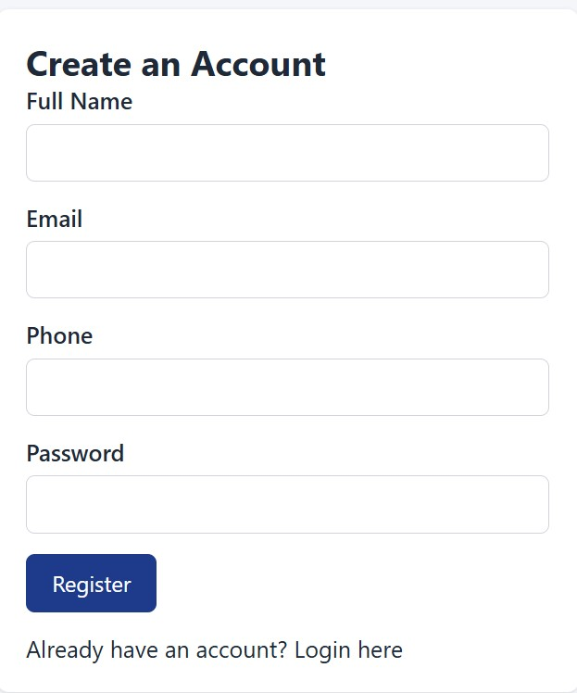
- Common Dashboard For Complaint : Users can submit new complaints and view their complaint history. Each complaint displays its status (Pending, Assigned, Resolved) and assigned agent.

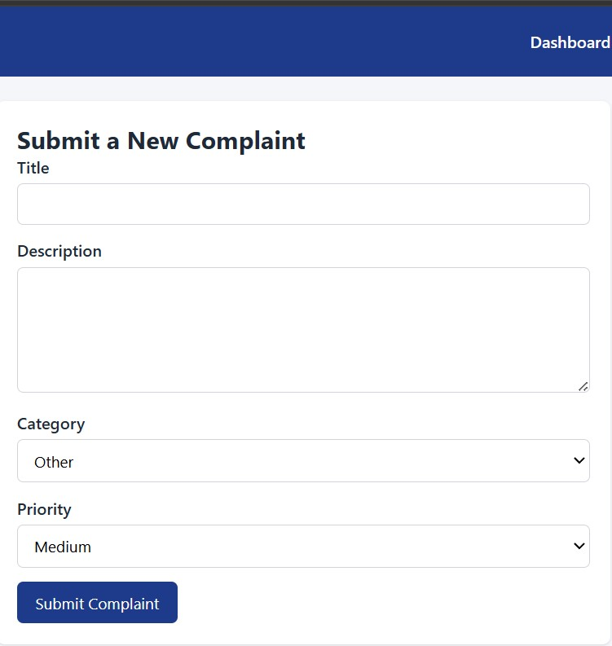

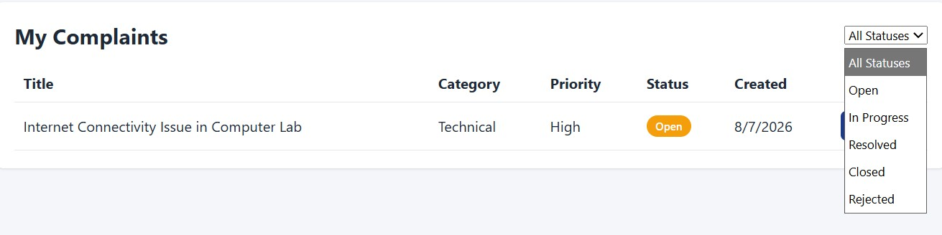
Admin Dashboard : Shows complaints assigned to the agent with their details.
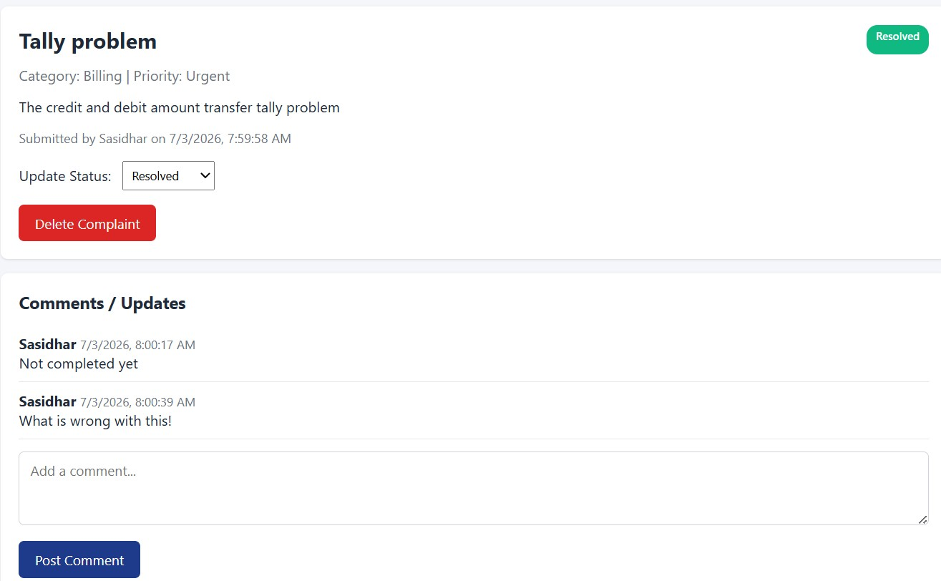
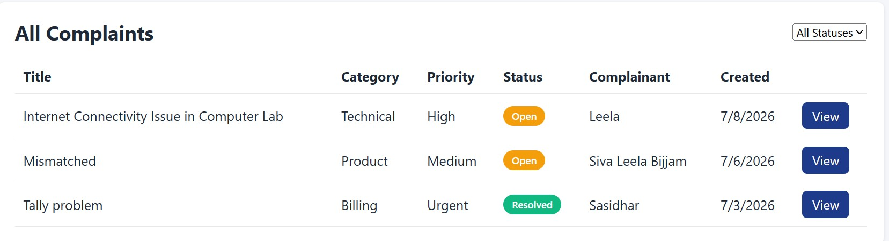
Admin can update the status of complaints (e.g., In Progress, Resolved).
DEMO LINKS

https://drive.google.com/drive/folders/1IkNXwpGQBzt8yEjwa_ZvOKtdmLVr7be

